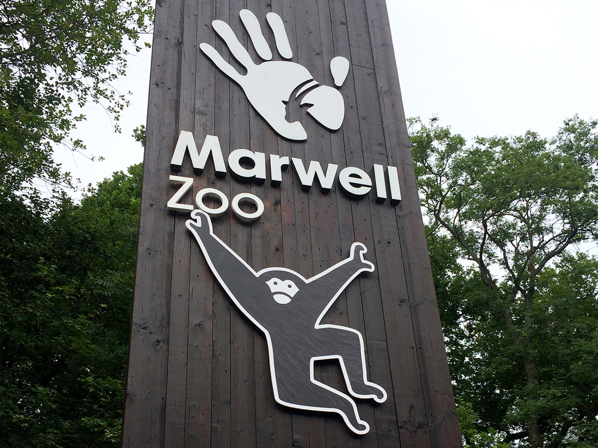

About Marwell Zoo Park

What is Marwell Park Zoo? and where is located established? Marwell Zoo, located in Colden Common near Winchester, Hampshire, England, is a 140-acre park home to over 1,200 animals representing 149 species. Established in 1972 by John Knowles, it is operated by Marwell Wildlife, a registered charity dedicated to wildlife conservation.

Opening & Closed Timings

The zoo opens daily at 10:00 AM To 8:00 PM.

Last admission is 90 minutes before closing, and animal houses begin to close 30 minutes before the park closes.

Marwell Zoo hosts various events throughout the year, including the "Glow Marwell" light experience during the winter season.

While there are no specific "Ladies' Days," the zoo offers family fun days and other activities suitable for all visitors.

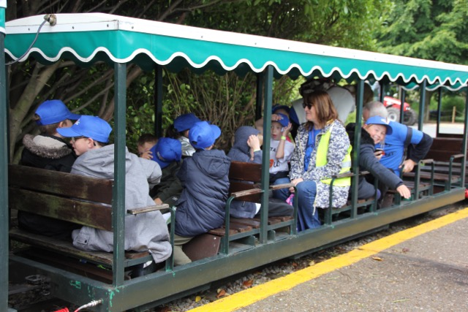

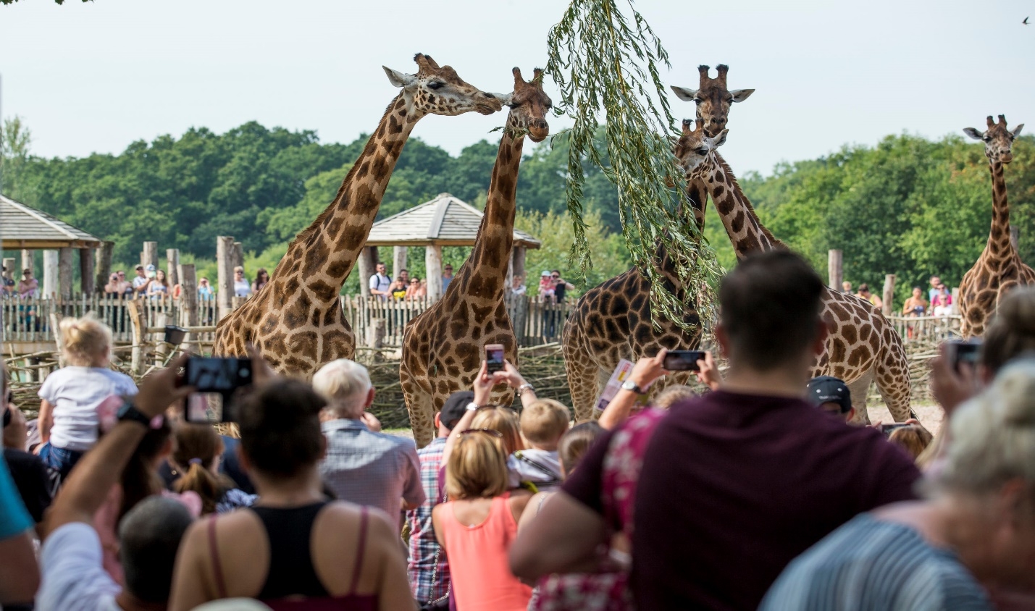

Animals List

As of December 31, 2024, Marwell Zoo in Hampshire, England, is home to over 140 species of animals.

Rothschilds giraffe

Snow leopard

White rhinoceros

Plains zebra

Yellow mongoose

Golden lion tamarin

Arabian oryx

Przewalskis horse

Humboldt penguin

Address & Contact

Address: Marwell Zoo, Thompsons Lane, Colden Common, Winchester, Hampshire, SO21 1JH, United Kingdom.

Email: For specific enquiries, you can fill out the contact form available on their marwell@marwell.org.uk.

Phone: For urgent enquiries, you can call their Supporter Contact team at +44 1962 777407.

For the most current information on events, ticket prices, and any seasonal variations in opening times, please visit the [official Marwell Zoo website](https://www.marwell.org.uk/).